GIT REPORT

* What is git ?

Git is a DevOps tool used for source code management. It is a free and open-source version control system used to handle small to very large projects efficiently. Git is used to tracking changes in the source code, enabling multiple developers to work together on non-linear development.

* What is github ?

GitHub is a web-based interface that uses Git, the open source version control software that lets multiple people make separate changes to web pages at the same time.

* What is VCS ?

Version control systems are a category of software tools that helps in recording changes made to files by keeping a track of modifications done in the code.

* What are localized, centralized, distributed VCS ?

A local VCS stores source files within a local system, a centralized VCS stores changes in a single server, and a distributed VCS involves cloning a Git repository.

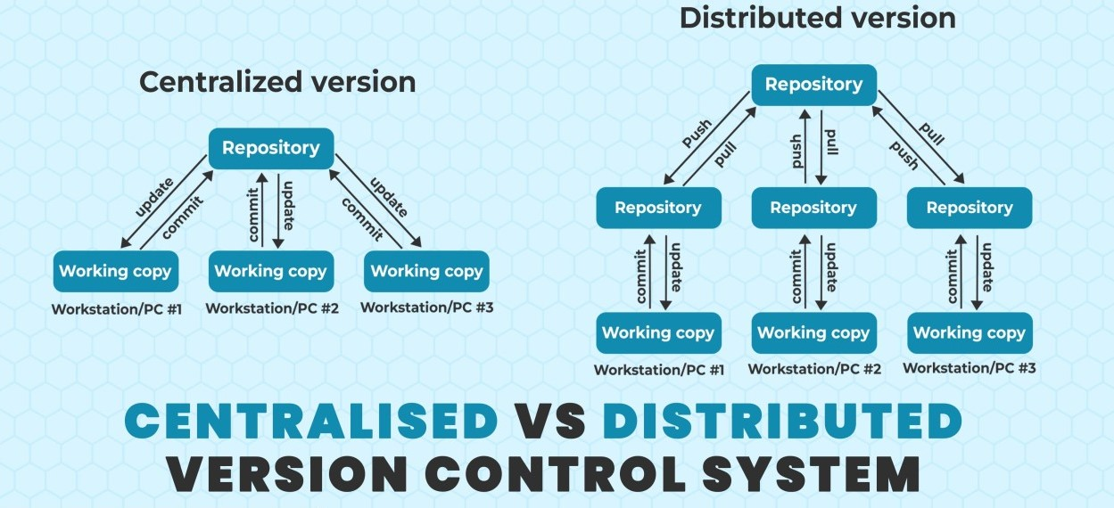

* What is git repository ?

The repositories of Github act as essential places for storing the files with maintaining the versions of development. By using GitHub repositories developers can organize, monitor, and save their changes of code to their projects in remote environments. The files in the GitHub repository are imported from the repository into the local server of the user for further updations and modifications in the content of the file.

* What are states if a git?

The states of a git are :

1. Working directory
2. Staging area
3. Git repository

**SOME IMPORTANT GIT COMMANDS**

* **Initialize a git repository :** git init
* **Get git configurations :** git config –list

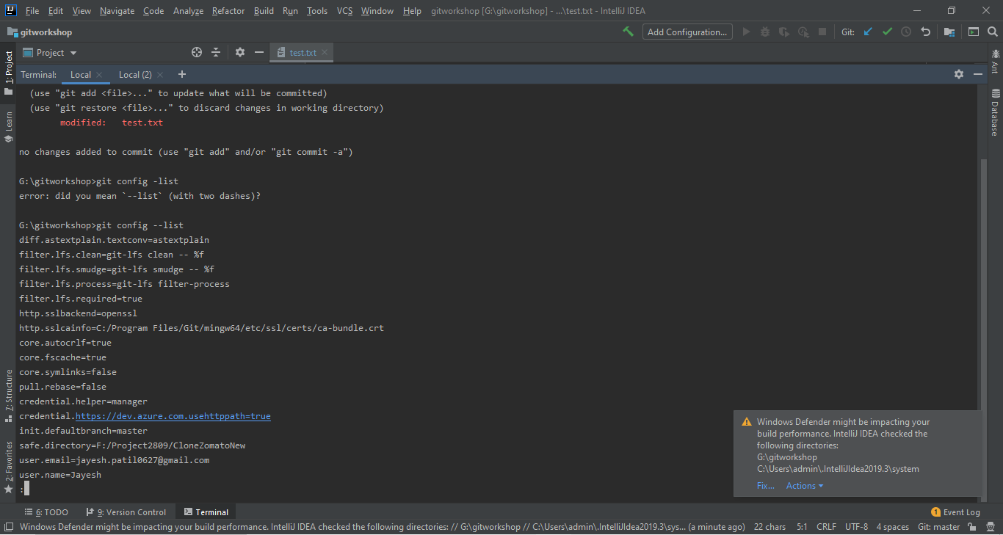

* **Get current status of git :** git status

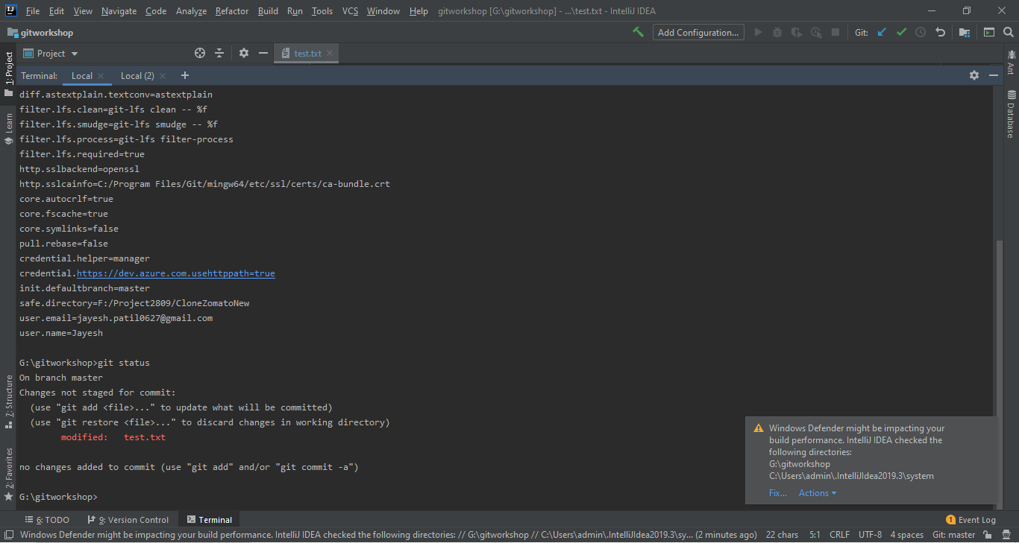

* **Add a file in git :** git add <file name>

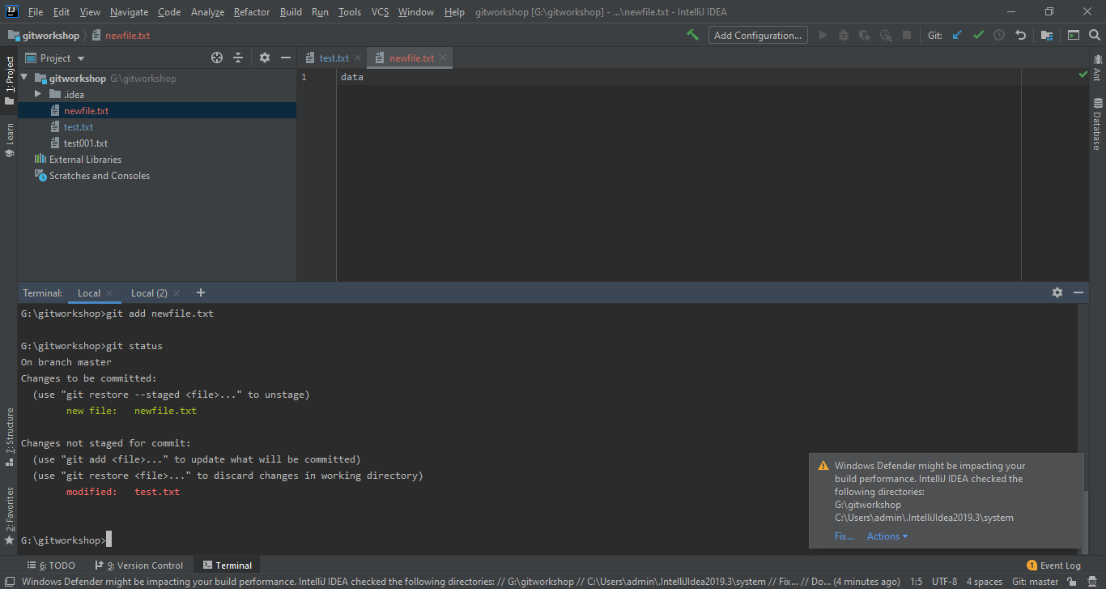

* **Add all files at once on git :** gitadd.
* **Commit changes in git :** git commit –m “commit message ”

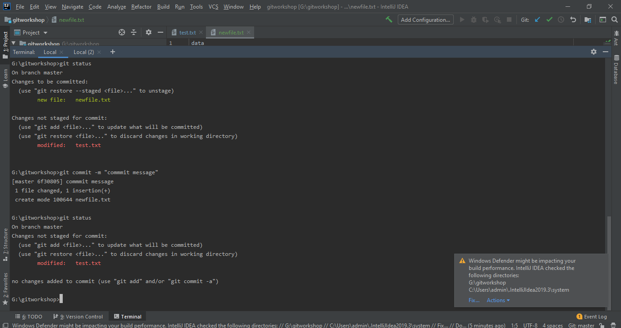

* **Fetch git history :** git –log
* **Make changes in last commit :** git commit –amend
* **Add files and commit with single command :** git commit –am “commit message ”
* **Get different changes :** git diff
* **To list all branches :** git branch
* **To checkout a new branch :** git checkout -<branchname>
* **To create a new branch :** git branch <branchName>
* **Merge a new branch :** git merge <branchname>
* **Rename a new branch :** git branch –m <old branch name> <new branch name>

